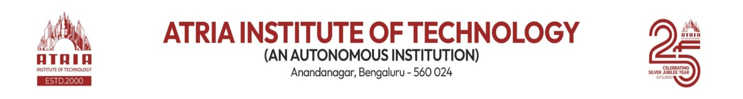

IEEE
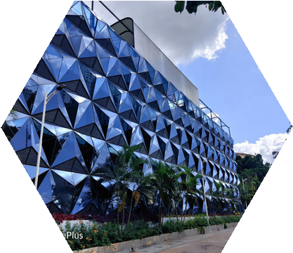
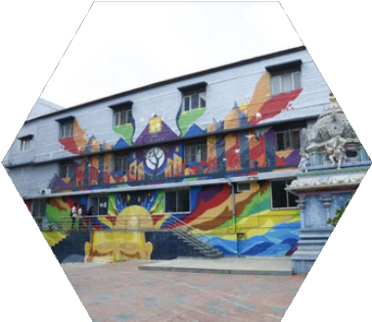
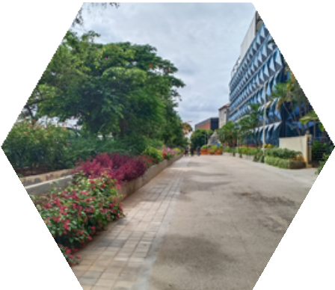

ACTIVITY REPORT

AY: 2023 – 24
DATE:
Faculty Convener:
Dr .Prasuna V N P

About Club

IEEE

INSTITUTEOF ELECTRICALS AND ELECTRONICS ENGINEERING


IEEE is the world's largest technical professional organization dedicated to advancing technology for the benefit of humanity. IEEE and its members inspire a global community through its highly cited publications, conferences, technology standards, and professional and educational activities.

About Event
TECH FIX RELAY CHALLENGE

This event is about decoding the code snippet provided in the langage of java and python.which helps students to enhance their decoding skills.
This event was conducted on 11-02-2024at 8:30am.This event was about python and java programming language participants were given code snippet to solve.There were about 9 participants participated from different department like MTTS,SIGHT,SPS etc.There were about 7 volunteers participated from different societies and department.

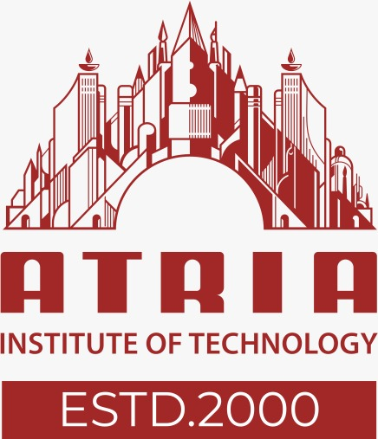

Registration Sheet

Sl. No | Name | USN | BRANCH | SEM &SEC
1 | Kavana T R | 1AT22EC039 | ECE | 6-B
2 | Sanika B G | 1AT22EC085 | ECE | 6-B
3 | Disha S | 1AT23CG041 | COMPUTER SCIENCE AND DESIGN | 4-B
4 | Sai Shreyas S | 1AT23EC145 | ECE | 4-B
5 | Chandu M | 1AT23CS033 | COMPUTER SCIENCE AND ENGINEERING | 4-A
6 | Digant S Hovale | 1AT23CS045 | COMPUTER SCIENCE AND DESIGN | 4-b
7 | Rithvik Ravindranath | 1AT23CG084 | COMPUTER SCIENCE AND DESIGN | 4-B
8 | Niranthar M javagal | 1AT23CG071 | COMPUTER SCIENCE AND DESIGN | 4-b

Gallery
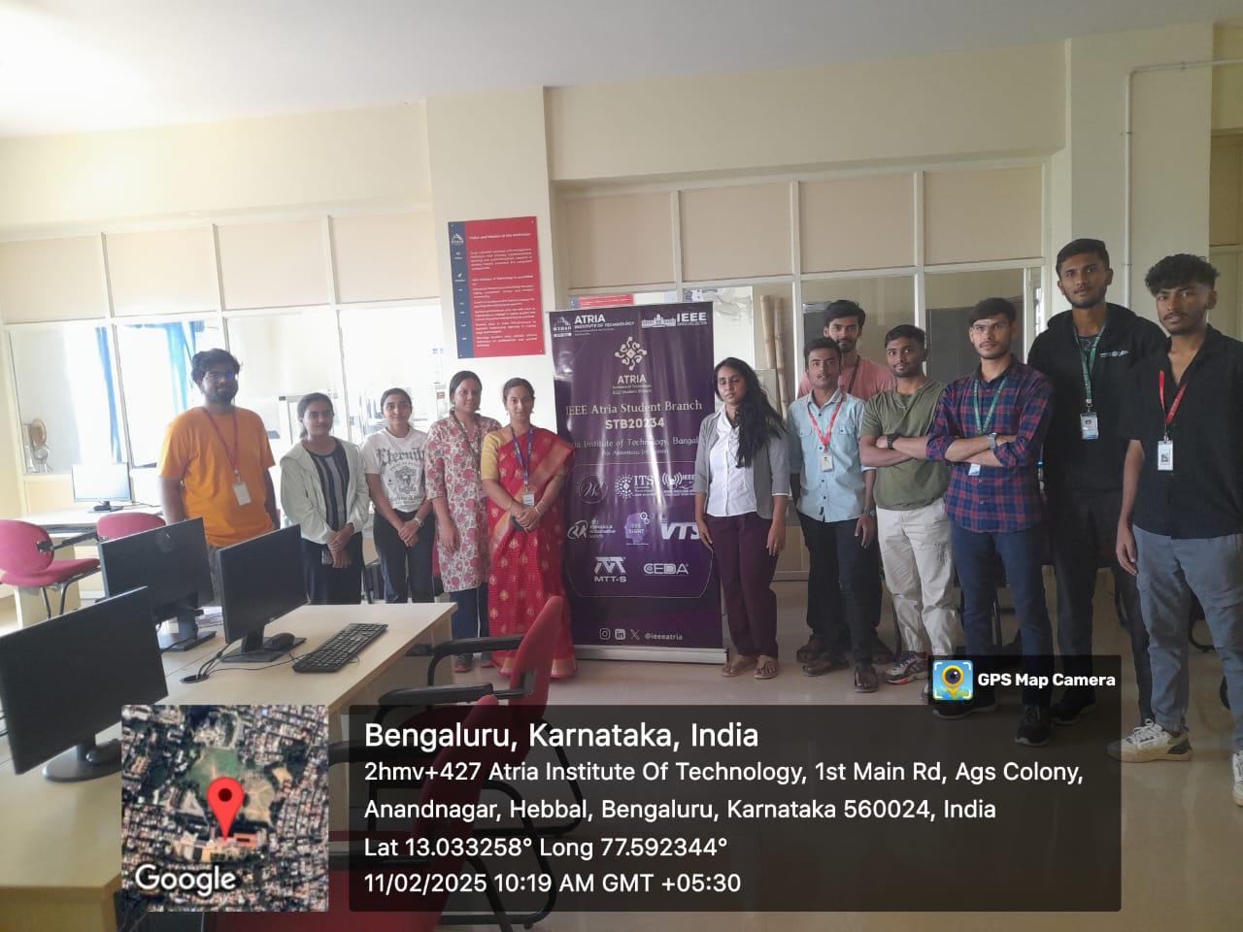  PICTURE OF PARTICIPANTS PARTICIPATED IN THE EVENT | PICTURE OF PARTICIPANTS DECODING THE GIVEN  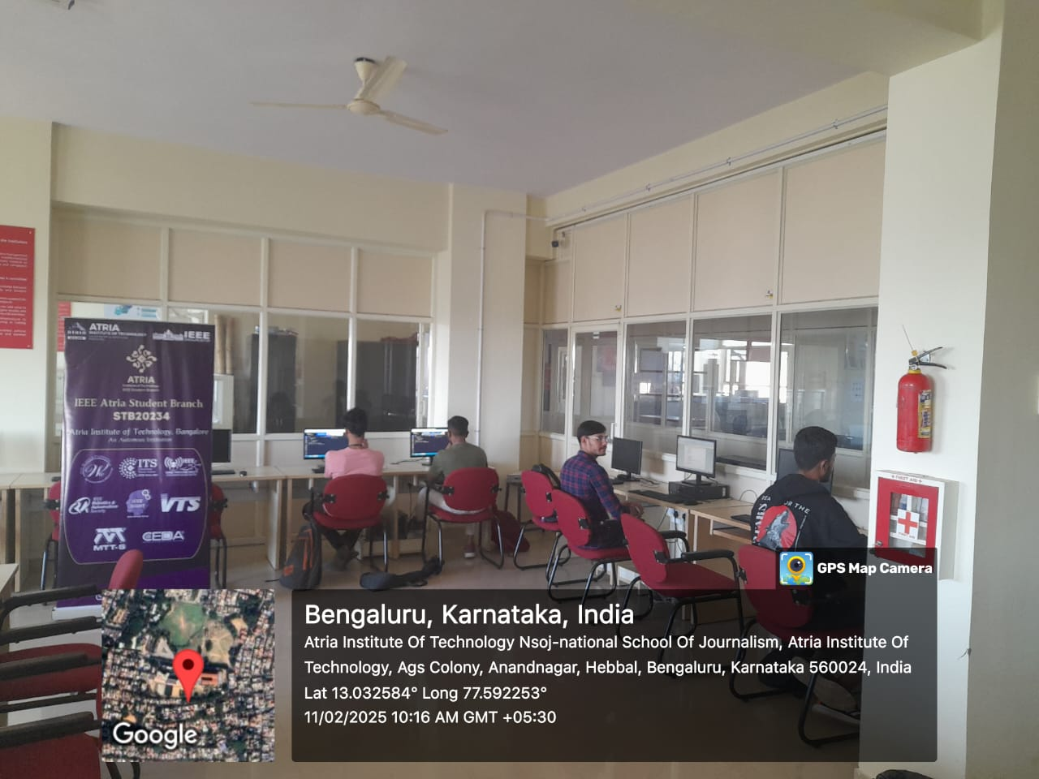  CODE SNNIPPET
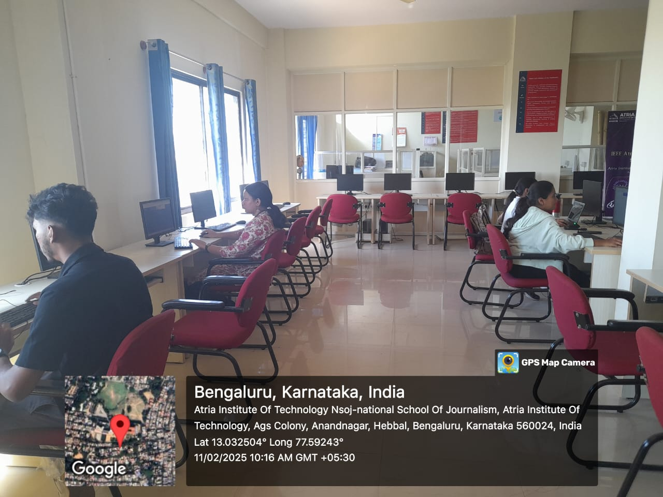 | 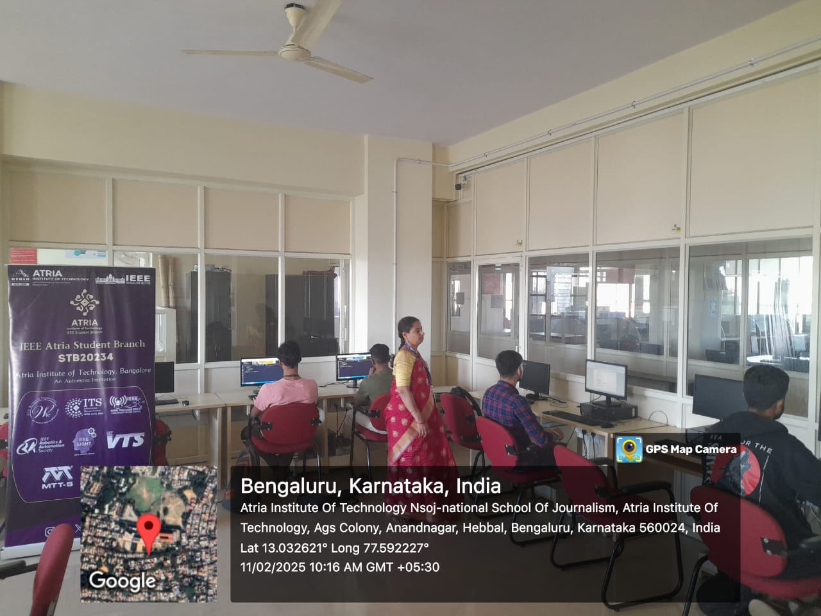
PICTURE OF PARTICIPANTS DECODING THE GIVEN  CODE SNNIPPET | Faculties joining the session

Feedback

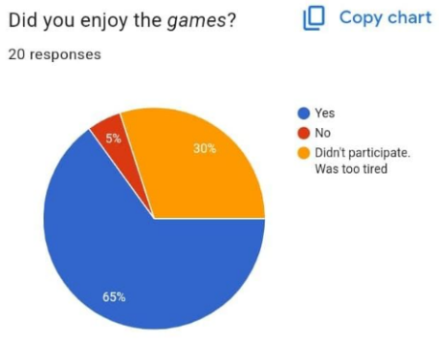

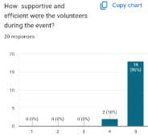

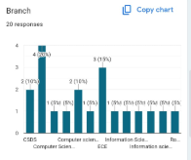

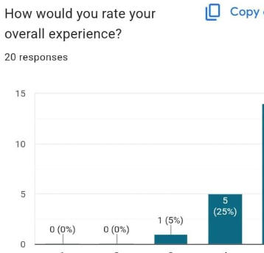
Conclusion
This event was successful.there were three runner ups 1st,2nd,&3rd
1st-Chandu M-1AT23CS033 from Computer Science & Engineering Dept
2nd-Digant S Hovale -1AT23CS045 Computer Science & Engineering Dept
3rdRithvik Ravindranath-1AT23CG084 Computer Science and design Dept

